1. Create a Website about your favorite anime characters.
2. Your site should have a list of 5 or more characters put into a JavaScript array.
3. When the page loads, display each character in a list item.
4. Allow the user to provide a new character into the array with an Add button
5. Also update the list to include the new character
6. Multiple Characters should be able to be added to the list

***(Display when the page loads)***

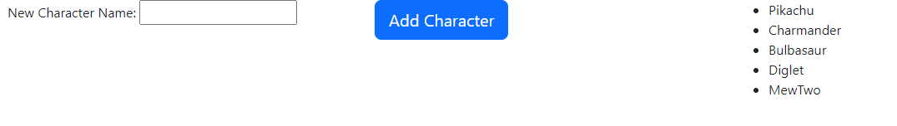

***(Display after multiple button clicks)***

